Title or Task: | Mathematics arithmetic-tricks  

Description:

Files Required
Suitable for Classes: | Mathematics
Area: | Technology & Enterprise
Teacher: | Mr Peter Faulks

Timeline

Date Due:

Task Brief:

Outcomes:

Items highlighted in yellow are tasks for you to complete
Items in Blue italics are help tips


Find more tricks to help you with Mathematics

IF plus is multiplied by plus = plus
+ x + = +
30 x 25 = 750

IF minus is multiplied by plus = minus
- x + = -
-30 x 25 = -750
IF minus is multiplied by minus = plus
- x - = +
-30 x -25 = 750

-3 + 5 = -2
- ( -3) = +3
+ ( -5) = -5
- ( +5) = -5
4 - ( -6) = 4+6

Division Rules

Minus ÷ Plus = Minus Plus ÷ Minus = Minus Minus ÷ Minus = Plus Plus ÷ Plus = Plus

* ⁼ ⁼ ⁼ Answer

http://www.sosmath.com/algebra/fraction/frac8/frac8.html

Multiply By 4
To quickly multiply by four, double the number and then double it again.
Often this can be done in your head.
Try 25 = double = 50, +50 = 100

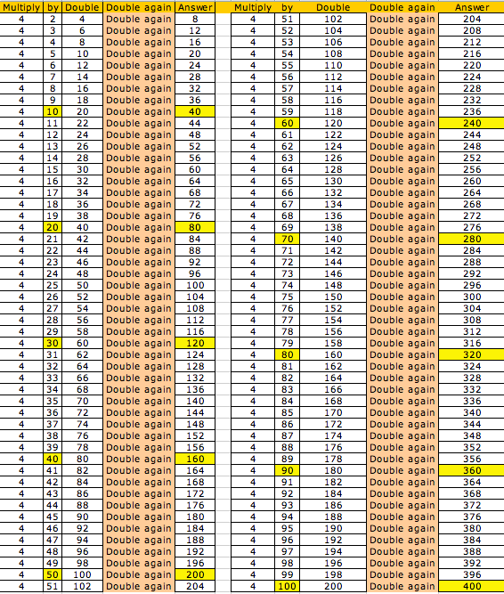

Multiply by 4
This is a very simple trick which may appear obvious to some, but to others it is not. The trick is to simply multiply by two, then multiply by two again:
58 x 4 = (58 x 2) + (58 x 2) = (116) + (116) = 232

Multiply By 5
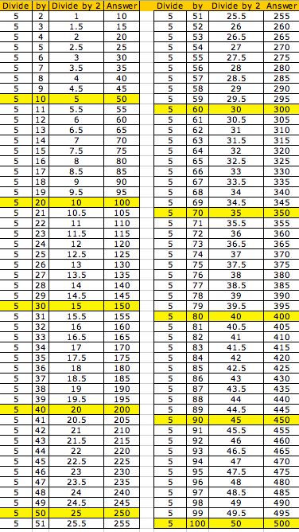
To quickly multiply by 5, divide the number in two and then multiply it by 10. Often this can be done quickly in your head. If it is an odd number just remove the decimal point.

5 x 29 = 14.5 but make it 145

5 x 61 = 30.5 but make it 305

5 x 88 = 44 add 0 = 440

5 x 98 = 49 add 0 = 490

Multiply by 5
Most people memorize the 5 times tables very easily, but when you get in to larger numbers it gets more complex – or does it? This trick is super easy.
Take any number, then divide it by 2 (in other words, halve the number). If the result is whole, add a 0 at the end. If it is not, ignore the remainder and add a 5 at the end. It works every time:
2682 x 5 = (2682 / 2) & 5 or 0
2682 / 2 = 1341 (whole number so add 0)
13410
Let’s try another:
5887 x 5
2943.5 (fractional number (ignore remainder, add 5)
29435

9. Finger Math: 9X Rule

To multiply by 9,try this: 9 x 3
(1) Spread your two hands out and place them on a desk or table in front of you.
(2) To multiply by 3, fold down the 3rd finger from the left. To multiply by 4, it would be the 4th finger and so on. 9 x 3 = 3rd finger left leave 2 fingers and to the right seven fingers so write 2 and 7 = 27
(3) the answer is 27 ... READ it from the two fingers on the left of the folded down finger and the 7 fingers on the right of it.
This works for anything up to 9 x 10!

9 x 5 sample

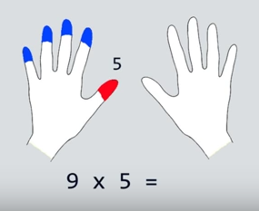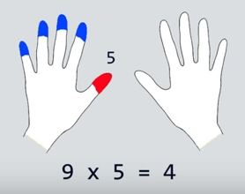
Find 5th digit left hand Counting left = 4
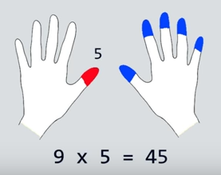
Counting right we have 5 so insert the 5 answer 45

Multiply anything in your head

20 Multiply Up to 20X20 In Your Head

In just FIVE minutes you should learn to quickly multiply up to 20x20 in your head. With this trick, you will be able to multiply any two numbers from 11 to 19 in your head quickly, without the use of a calculator.
I will assume that you know your multiplication table reasonably well up to 10x10.
Try this:
- Take 15 x 13 for an example.
- Always place the larger number of the two on top in your mind.
- Then draw the shape of Africa mentally so it covers the 15 and the 3 from the 13 below. Those covered numbers are all you need.
- First add 15 + 3 = 18
- Add a zero behind it (multiply by 10) to get 180.
- Multiply the covered lower 3 x the single digit above it the "5" (3x5= 15)
- Add 180 + 15 = 195.
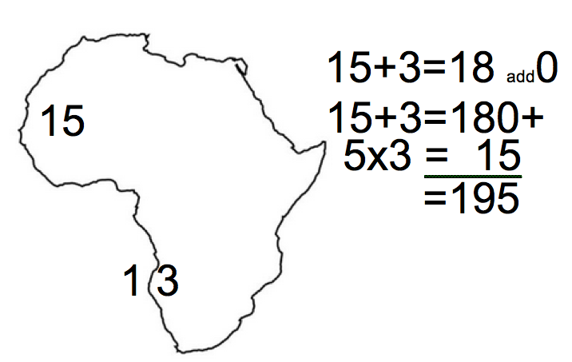

That is It! Wasn't that easy? Practice it on paper first!

Square a 2 Digit Number Ending in 5
For this example we will use 25
- Take the "tens" part of the number (the 2 and add 1)=3
- Multiply the original "tens" part of the number by the new number (2x3)
- Take the result (2x3=6) and put 25 behind it. Result the answer 625.
Try a few more
75 squared ... = 7x8=56 ... put 25 behind it is 5625.
7+1 = 8 the 7x8 – 56 add 25 = 5625
55 squared = 5x6=30 ... put 25 behind it ... is 3025.
5+1 = 6 5x6 = 30 add 25 = 3025
Another easy one! Practice it on paper first!

Square 2 Digit Number: UP-DOWN Method
Square a 2 Digit Number, for this example 37:
- Look for the nearest 10 boundary
- In this case up 3 from 37 to 40.
- Since you went UP 3 to 40 go DOWN 3 from 37 to 34.
- Now mentally multiply 34x40
- The way I do it is 34x10=340;
- Double it mentally to 680
- Double it again mentally to 1360
- This 1360 is the FIRST interim answer.
- 37 is "3" away from the 10 boundary 40.
- Square this "3" distance from 10 boundary.
- 3x3=9 which is the SECOND interim answer.
- Add the two interim answers to get the final answer.
- Answer: 1360 + 9 = 1369

The 11 Times Trick
We all know the trick when multiplying by ten – add 0 to the end of the number, but did you know there is an equally easy trick for multiplying a two digit number by 11? This is it:
Take the original number and imagine a space between the two digits (in this example we will use 52:
5_2
Now add the two numbers together and put them in the middle:
5_(5+2)_2
That is it – you have the answer: 572.
The only thing tricky to remember is that if the result of the addition is greater than 9, you only put the "ones" digit in the hole and carry the "tens" digit from the addition.
100 10 0
Digits hundred tens One
For example 11 x 57 ... 5__7 ... 5+7=12 ... put the 2 in the hole and add the 1 from the 12 to the 5 in to get 6 for a result of 627 ... 11 x 57 = 627
Practice it on paper first!

If the numbers in the middle add up to a 2 digit number, just insert the second number and add 1 to the first:
9_(9+9)_9 = 9 (18) 9 (add the one to the left 9 =10 and leave the 8 in place)
(9+1)_8_9
10_8_9
1089 – It works every time.
The 11 Rule Expanded
You can directly write down the answer to any number multiplied by 11.

Take for example the number 51236 X 11.

First, write down the number with a zero in front of it.
051236

The zero is necessary so that the rules are simpler.

Draw a line under the number.
051236

Bear with me on this one. It is simple if you work through it slowly. To do this, all you have to do this is "Add the neighbor" the number to the right of it.

Look at the 6 in the "units" position of the number. Since there is no number to the right of it, you can't add to its "neighbor" so just write down 6 below the 6 in the units col.

051236
6
For the "tens" place, add the 3 to the its "right neighbor" (the 6). Write the answer: 9 below the 3.
051236 = 3+6 = 9
96
For the "hundreds" place, add the 2 to the its "neighbor" (the 3). Write the answer: 5 below the 2.
051236 = 2+3 =5
596
For the "thousands" place, add the 1 to the its "neighbor" (the 2). Write the answer: 3 below the 1.
051236 = 1+2 =3
3596
For the "ten-thousands" place, add the 5 to the its "neighbor" (the 1). Write the answer: 6 below the 5.
051236 = 5+1 =6
63596
For the "hundred-thousands" place, add the 0 to the its "neighbor" (the 5). Write the answer: 5 below the 0.
051236 = 0+5 =5
563596
That's it ... 11 X 051236 = 563596

2. Quick Square
If you need to square a 2 digit number ending in 5, you can do so very easily with this trick. Mulitply the first digit by itself + 1, and put 25 on the end. That is all!
25² = (2x(2+1)) & 25
2 x 3 = 6
625

6. Calculate a Tip
If you need to leave a 15% tip, here is the easy way to do it. Work out 10% (divide the number by 10) – then add that number to half its value and you have your answer:
15% of $25 = (10% of 25) + ((10% of 25) / 2)
$2.50 + $1.25 = $3.75
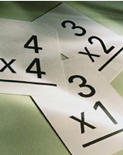
Sample Restaurant bill $154.00
Tip 15% is $15.40 (10%) plus half of $15.40 = $7.70
Add $15.40 and $7.70 = $23.10
If Tip is 10% it is $15.40 or 1% is $1.54
Multiply 1% of bill ($1.54) by percentage required
18% = $1.54 x 18 = $27.72
20% = $1.54 x 20 = $30.80

7. Tough Multiplication
If you have a large number to multiply and one of the numbers is even, you can easily subdivide to get to the answer:
32 x 125, is the same as:
16 x 250 is the same as:
8 x 500 is the same as:
4 x 1000 = 4,000

8. Dividing by 5
Dividing a large number by five is actually very simple. All you do is multiply by 2 and move the decimal point:
195 / 5
Step1: 195 * 2 = 390
Step2: Move the decimal: 39.0 or just 39
2978 / 5
step 1: 2978 * 2 = 5956
Step2: 595.6

9. Subtracting from 1,000
To subtract a large number from 1,000 you can use this basic rule: subtract all but the last number from 9, then subtract the last number from 10:
1000
-648
step1: subtract 6 from 9 = 3
step2: subtract 4 from 9 = 5
step3: subtract 8 from 10 = 2
answer: 352

10. Assorted Multiplication Rules
Multiply by 5: Multiply by 10 and divide by 2.
Multiply by 6: Sometimes multiplying by 3 and then 2 is easy.
Multiply by 9: Multiply by 10 and subtract the original number.
Multiply by 12: Multiply by 10 and add twice the original number.
Multiply by 13: Multiply by 3 and add 10 times original number.
Multiply by 14: Multiply by 7 and then multiply by 2
Multiply by 15: Multiply by 10 and add 5 times the original number, as above.
Multiply by 16: You can double four times, if you want to. Or you can multiply by 8 and then by 2.
Multiply by 17: Multiply by 7 and add 10 times original number.
Multiply by 18: Multiply by 20 and subtract twice the original number (which is obvious from the first step).
Multiply by 19: Multiply by 20 and subtract the original number.
Multiply by 24: Multiply by 8 and then multiply by 3.
Multiply by 27: Multiply by 30 and subtract 3 times the original number (which is obvious from the first step).
Multiply by 45: Multiply by 50 and subtract 5 times the original number (which is obvious from the first step).
Multiply by 90: Multiply by 9 (as above) and put a zero on the right.
Multiply by 98: Multiply by 100 and subtract twice the original number.
Multiply by 99: Multiply by 100 and subtract the original number.

Bonus: Percentages
Find 7 % of 300. Sound Difficult?
Percents: First of all you need to understand the word “Percent.” The first part is PER , as in 10 tricks per listverse page. PER = FOR EACH. The second part of the word is CENT, as in 100. Like Century = 100 years. 100 CENTS in 1 dollar… etc. Ok… so PERCENT = For Each 100.
So, it follows that 7 PERCENT of 100, is 7. (7 for each hundred, of only 1 hundred).
8 % of 100 = 8. 35.73% of 100 = 35.73
But how is that useful??
Back to the 7% of 300 question. 7% of the first hundred is 7. 7% of 2nd hundred is also 7, and yep, 7% of the 3rd hundred is also 7. So 7+7+7 = 21.
If 8 % of 100 is 8, it follows that 8% of 50 is half of 8 , or 4.
Break down every number that’s asked into questions of 100, if the number is less then 100, then move the decimal point accordingly.
EXAMPLES:
8%200 = ? 8 + 8 = 16.
8%250 = ? 8 + 8 + 4 = 20.
8%25 = 2.0 (Moving the decimal back).
15%300 = 15+15+15 =45.
15%350 = 15+15+15+7.5 = 52.5
Also it’s usefull to know that you can always flip percents, like 3% of 100 is the same as 100% of 3.
35% of 8 is the same as 8% of 35.

Keyboard shortcuts
On the Mac, there are a few keyboard shortcuts by pressing and holding the Option/Alt key (⌥) whilst pressing another character on the keyboard.
Or a combination of the Option/Alt key and the Shift key (⇧).
For example, the division symbol (÷) is ⌥ and /.
÷

The degree symbol (°) is ⇧ and ⌥ and 8.
°

See the download below for a cheat sheet with more shortcuts.

Word’s Object Palette
In Word 2008 for Mac (I think the previous version has this as well) open the Toolbox. At the top there are tabs for various parts of the Toolbox. The second one is the Object Palette (click thumbnail below for a larger view). Then, select the copyright symbol (©) which takes you to a palette of symbols. Clicking a symbol here will insert it into your documents.
$±$ —5
——
This is the quickest way I can find to insert a multiplication symbol without using more complex methods described below.

AutoCorrect
Have you noticed how Word automagically corrects common spelling mistakes? That’s called AutoCorrect, and I think this might be the best way to insert commonly used symbols that don’t have a keyboard shortcut.
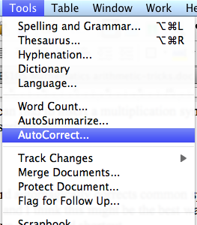
I’ll use the multiplication symbol as an example. First, you will need to use the previous method to insert a multiplication symbol into a new document. Then, copy that symbol to the clipboard. From the Tools menu select AutoCorrect. Make sure “Replace text as you type” is selected. In the “Replace:” field type an uncommon phrase that will be replaced with the multiplication symbol. I use &times, because it’s very similar to how you insert symbols in HTML (the language for writing web pages). In the “With:” field paste the multiplication symbol you copied earlier (i.e. click in the field and press Command ⌘ and v at the same time). Press the Add button and then the OK button. Click the thumbnail below for a screenshot.
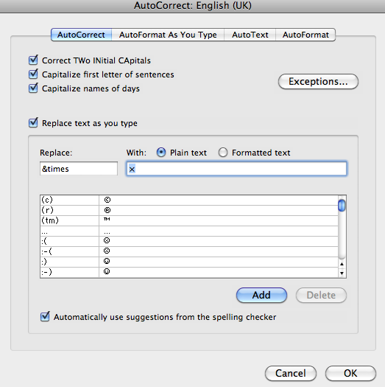
Now when you type &times into a Word document it will automatically be replaced with ×.
USING AUTO CORRECT
NOTE: When typing an essay I use Auto Correct to replace large text, for instance if I am writing about Corona Virius (Codvid-19) and I don't want to type this every time, I can put the following into Auto correct and using cv1 as my replace word when I type cv1 it will replace that with Corona Virius (Codvid-19). Use only two letters and a number so that the code in unique.

Character Palette
The Character Palette is a Mac OS X tool for inserting symbols into any application. I’ll leave it to Apple’s help page to explain this method:
Typing special characters and symbols

Unicode
Even more complex than the previous method, use the symbol’s Unicode code! To do this, you will need to setup as per the previous method – which means there should be a flag at the top-right of your screen on the menu bar. You then need to go to System Preferences from the Apple menu, select International and then the Input Menu tab. There’s a long list of input methods/languages here, you need to look for “Unicode Hex Input” and select it. [source]
Now, to insert say the multiplication symbol, from the flag menu select “Unicode Hex Input”, now hold down the Option/Alt key (⌥) and type the Unicode hex code for × which is 00D7. These codes are not ones you are likely to remember. In my previous article, there’s a cheat sheet. Have a look in that file for a column “Type then Alt+x” – the codes in that column are Unicode. There are lots of charts on the official Unicode site.

Conclusion

MATHEMATICS
listverse.com/2007/09/17/10-easy-arithmetic-tricks/ -


